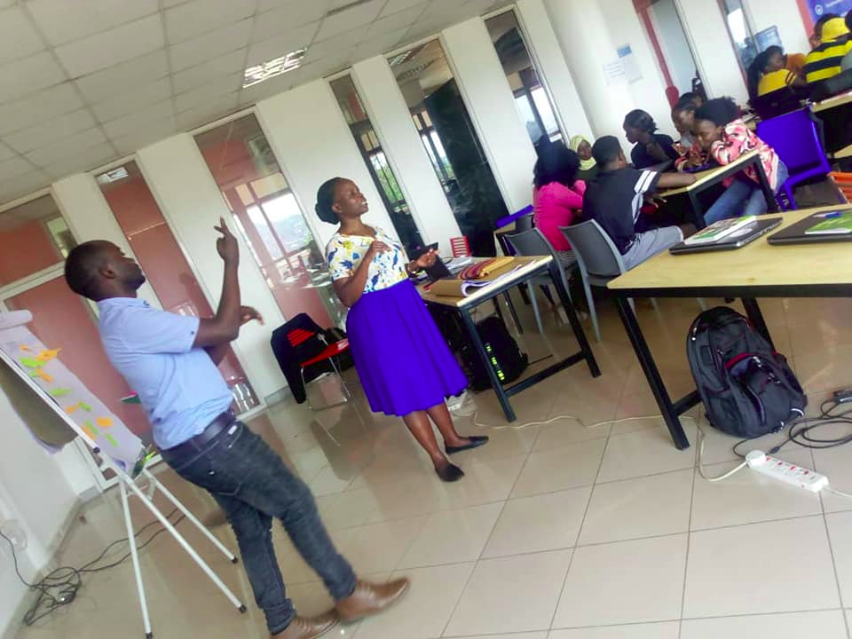

How inclusive Are We!

Robert was born perfectly normal and healthy. He grew up like any other fully able child until the age of seven. At the age of seven he got a sever one day, it was treated as a regular fever but one afternoon he when to rest and strangely the rest took much longer than usual when he was finally awoken he realized he had lost his sense of hearing. He was suddenly deaf!

Very disturbing to say the least, especially for a young boy of his age, however, he took it well had support from his mother but the further wanted nothing to do with him. The father couldn't get himself to accept his predicament, he refused to support Robert's education, but God was with him, the mother supported him all through to university.

While attending the Edu program at Outbox Robert talked to us about reasonable accommodation and disability inclusion. He educated us about the plight of people with disabilities and the need for society to change its general outlook and behavior towards people with disabilities

Growing up, we had all sorts of names for people with disabilities. We called them, kasiru for the deaf (loosely translated as stupid), Koloba for the lame and Nanana for those who struggled with speech. I remember a boy in my primary school at Molly and Paul in Kibuye who would take close to a minute to say one word. Instead of being helpful we simply laughed at him and joked about it. To us it was a fun moment, we had total disregard for their pain and struggle.

Looking back now, I know that we where portraying total ignorance and lack of compassion for humans like with involuntary impairments. As children, no one talked to us about inclusion and reasonable accommodation. I believe it is why I felt a pang of strong guilt especially for my childhood days when Robert talked to us at Outbox. Everyone young and old should hear this.

Robert mentioned in this talk, that no one chooses to be born without limbs or unable to see or talk. No one chooses to get an accident or disease that takes away a part of their senses or ability. It can happen to anyone of us at whatever age. We have seen this happen, a perfectly normal person today gets an accident a loses an arm, a leg or both and ends up on crutches or in a wheelchair. People have lost sight and memory due to illness. These face it even rougher than those born with the impairment because they have to adapt to the new situation.

It is an uphill task when you are already of age, I can attest to it. A suffered blood clots in the brain from an accident last year which required an operation to save my life. For a while, I struggled to talk, couldn't see clearly, could not walk with aid and I could not remember things. Imagine all that for one person, I felt like my life had come to an end, the doctor reassured us that with consistent medication my senses would return but he couldn't guarantee to what percentage.

I felt very disturbed, it was so disheartening not being able to see, and remember especially. I barely did anything on my own, luckily for me, I had a very supportive family and friends. They were willing to anything for me. Though I felt sad imagining how life is going to be, how my family is going to cope and all that. I was comforted by the fact that I was surrounded by people who care.

That's the kind of support that anyone with any form of disability should and ought to have. They need to feel that society is for them and not against them. They should be able to get the required assistance to go through life without prejudice. It is our responsibility to stop discrimination. What is affecting them today may affect you or the people you love tomorrow.

The country needs to be sensitized, disability is not a curse. That disabled child that you refuse to educate may turn out to be a very important person in the country. We need to have national wide talks, in communities, schools and other institutions. We need to have a deliberate effort to make everyone appreciate persons with disabilities, we need to be accommodating and include persons with disabilities in all spheres of life. We have political talk shows on the radio every week, why not have a show every month countrywide on reasonable accommodation and inclusion.

Disability discrimination stops today. Inclusion for all.

Robert is a Disability Inclusion Facilitator at Light For The World.

